**IDEATION PHASE**

**BRAINSTORM**

|  |  |
| --- | --- |
| Date | 1 November 2022 |
| Team ID | PNT2022TMID22879 |
| Project name | Project-Smart Farmer-IoT enabled smart farming application. |
| Marks | 4Marks |

**STEP 1:Team gathering, collaboration and select the problem statement**

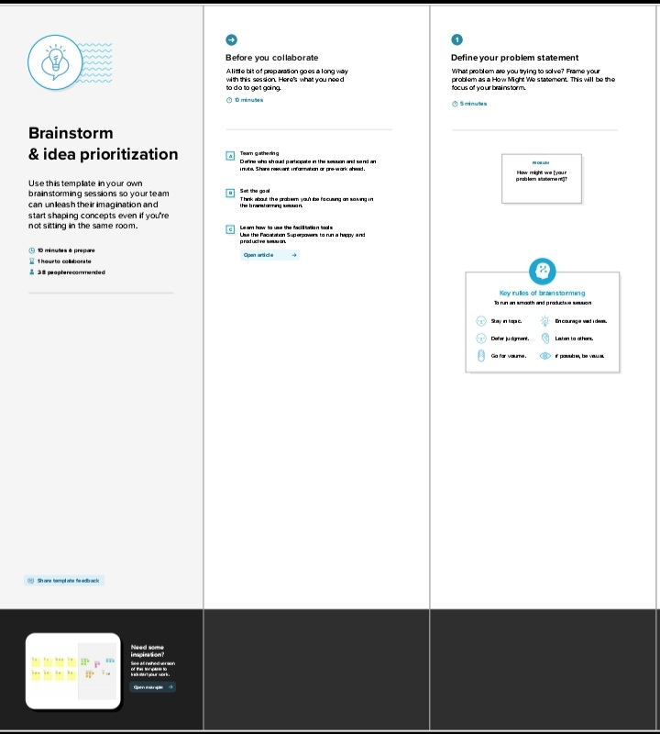

**STEP 2: Brainstorm idea listing**

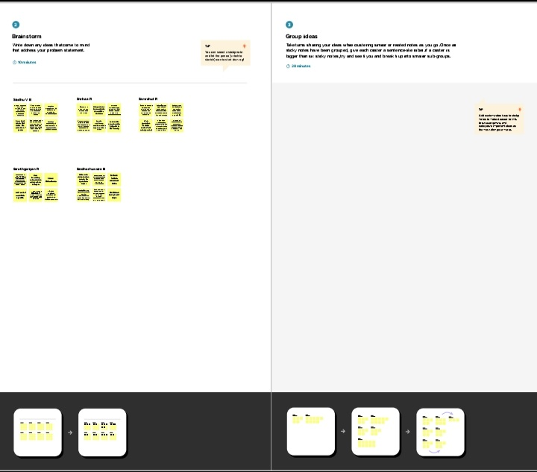

**STEP 3: Grouping**

